COMP 307 Assignment #4:

Installing XAMPP and DVWA

Written by: Kevin Ma | #300867968

1. Download the files from <http://e.centennialcollege.ca>
   1. XAMPP
   2. DVWA
2. Extract XAMPP and DVWA
3. Run the XAMPP installer

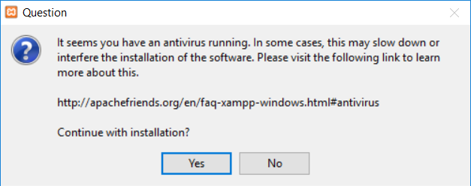

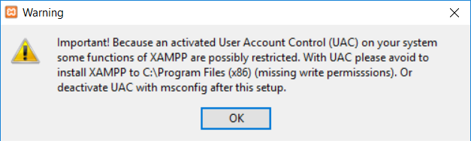

1. Keep all default configurations when prompted during installation

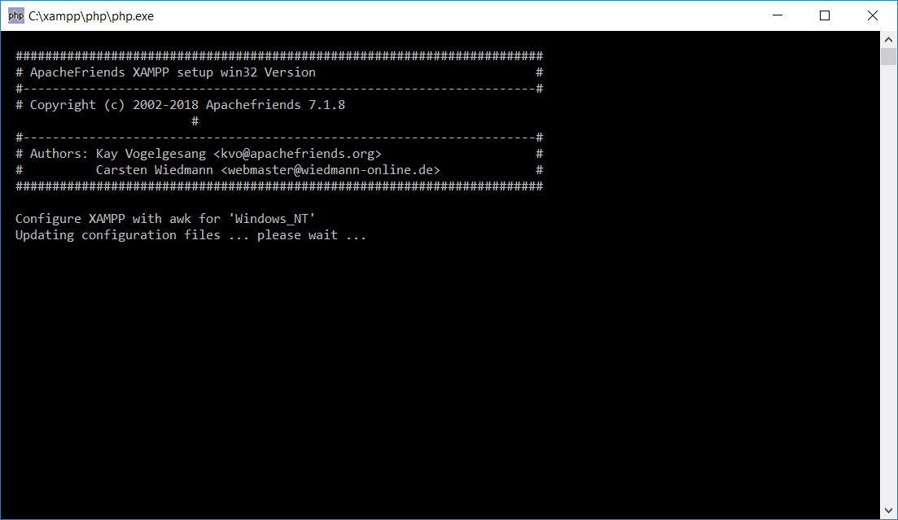

1. When installation is complete, open the control center and start the apache server

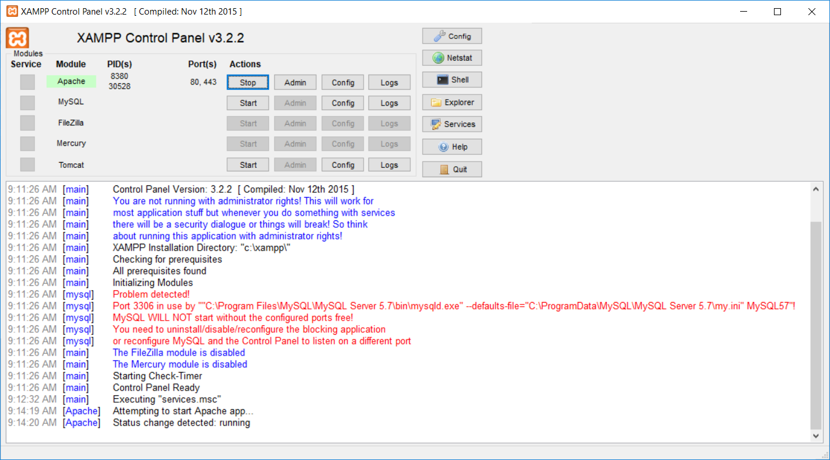

1. Turn off any local services running which may interfere with the XAMPP modules/ports (i.e. local MySQL)

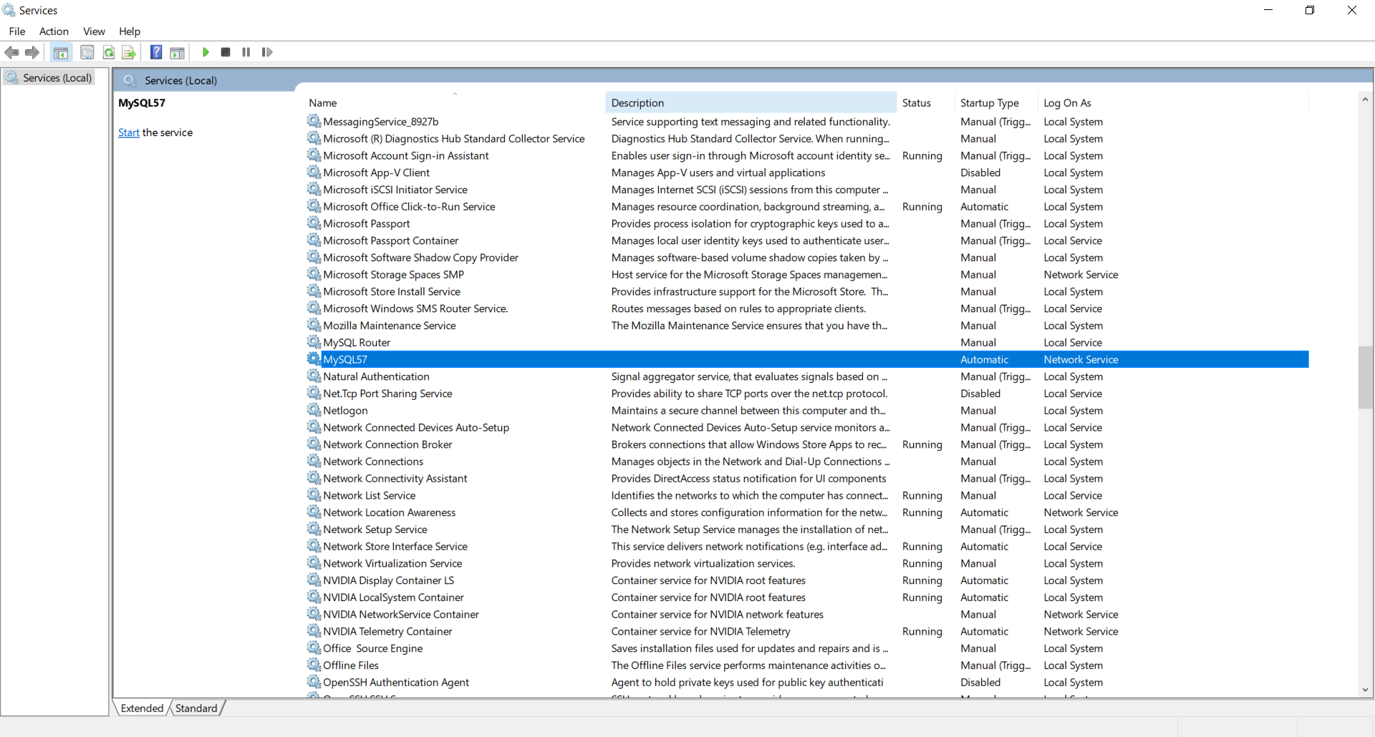

1. Turn on MySQL Module

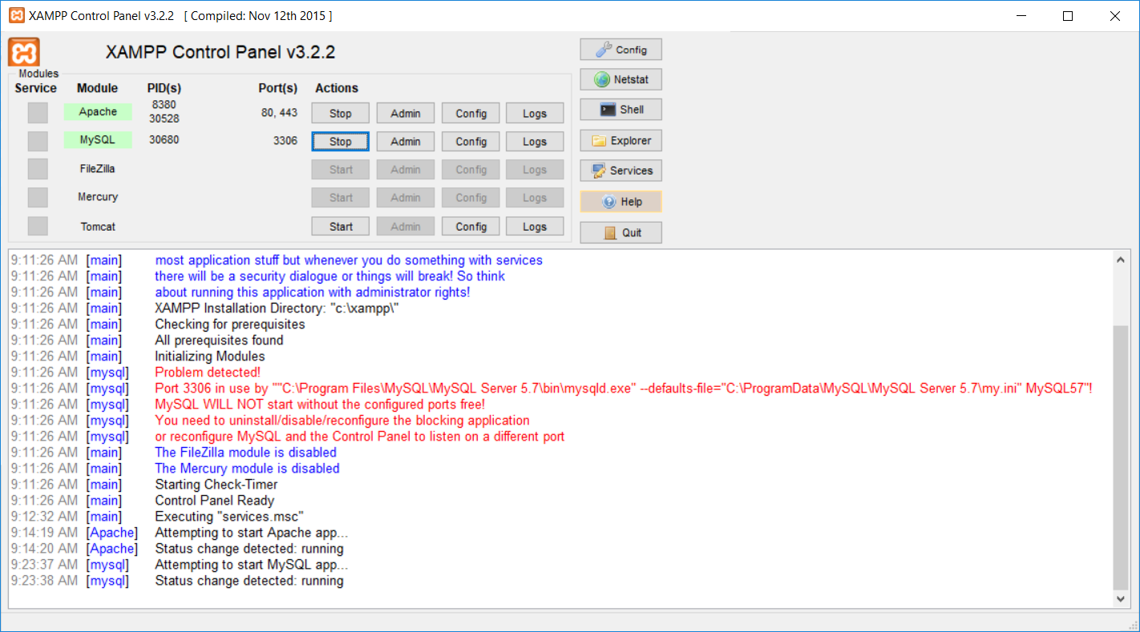

1. Copy the DVWA folder into the C:\xampp\htdocs folder
2. Modify the C:\xampp\htdocs\DVWA\config\config.inc.php file to have no passwords

$_DVWA[ 'db_password' ] = '';

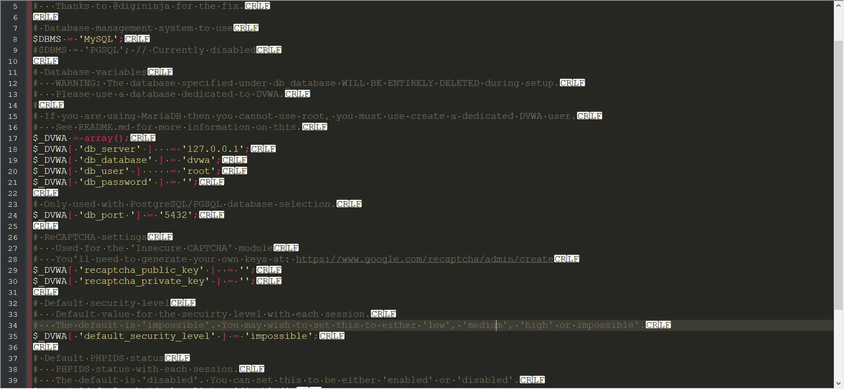

1. Go to <http://localhost/dvwa> in your browser and click on **create/reset database** at the bottom of the screen
2. Login with credentials **admin** and **password**
3. Explore the application and enjoy 😊!